SELinux Task
1.Check the current SELinux status on your Linux server using the getenforce and sestatus commands, and write down which mode (Enforcing, Permissive, or Disabled) is currently active.
1: Check the Current SELinux Status
I checked the current SELinux mode using the getenforce and sestatus commands.
Commands Used:
getenforce
sestatus
Observation:
The current SELinux mode was (write the output here: Enforcing / Permissive / Disabled).
The getenforce command displayed the active SELinux mode, while the sestatus command provided detailed information about the SELinux configuration and status.
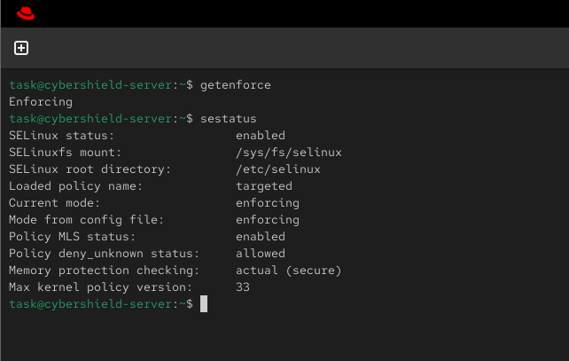
2.Switch SELinux to Enforcing mode using setenforce and verify the change with getenforce.<br>
<br><em><strong>Hint:</strong> You may need sudo privileges to change the mode.</em>
The system was already running in Enforcing mode. Therefore, no changes were required. I verified the current SELinux mode using the getenforce command.
Command Used:
getenforce
Result:
The output displayed Enforcing, confirming that SELinux was already running in Enforcing mode.
3.Simulate an SELinux access denial by creating a new directory (e.g., /tmp/testapp), setting its context to a type not allowed for your web server (such as user_home_t), and then try to serve a file from it using your web server. Note the error message in /var/log/audit/audit.log or /var/log/messages.
Step 1: Change the SELinux Context of a Web Page
I navigated to the Apache web server directory and created a new web page named testpage.html.
Commands Used:
cd /var/www/html
sudo nano testpage.html
I checked the current SELinux context of the file:
ls -Z testpage.html
Then, I changed the SELinux context to httpd_sys_content_t:
sudo chcon -t httpd_sys_content_t testpage.html
Finally, I verified the updated SELinux context:
ls -Z testpage.html
Result:
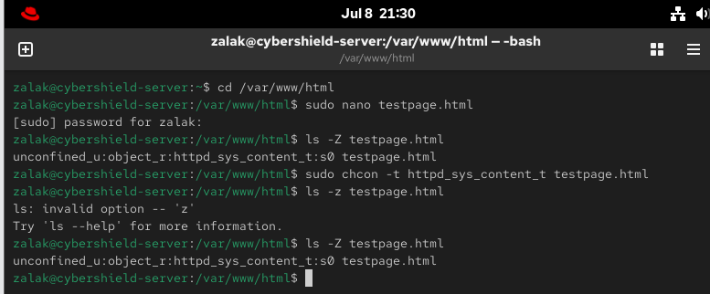
The SELinux type of the file was successfully changed to httpd_sys_content_t, allowing the Apache web server to access the file.

Question 4: Verify Web Server Access
I verified that the Apache web server was running and confirmed that the web page was accessible after assigning the correct SELinux context.
Commands Used:
sudo systemctl status httpd
If required:
sudo systemctl start httpd
sudo systemctl enable httpd
I opened the following URL in the web browser:
http://localhost/testpage.html
Result:
The web page loaded successfully, confirming that the httpd_sys_content_t SELinux context allowed Apache to access the file.
